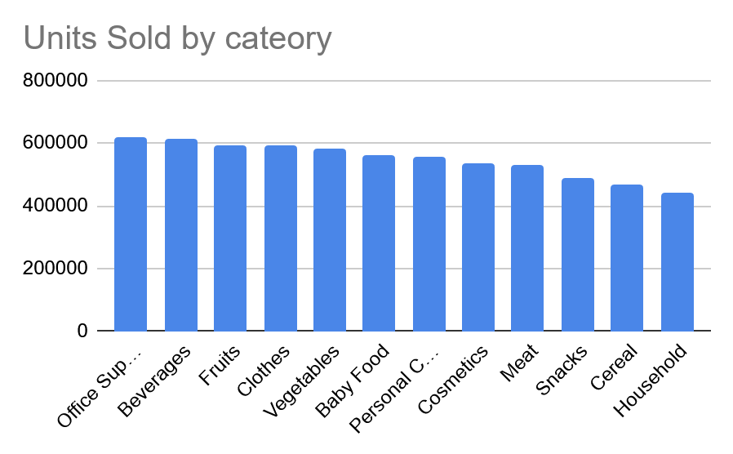
When looking at the overall units sold by category we notice that the most sold category is office supplies followed by beverages both with over 60K units sold. Fruits, clothes and vegetables follow closely with around 58-59k units sold

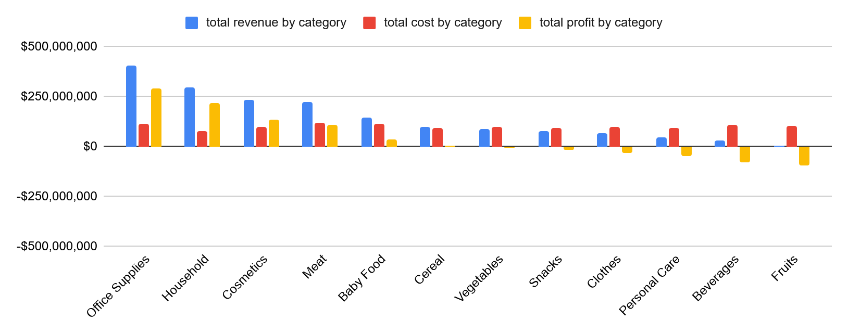
However when looking at the total profit by category we notice that beverages is second to last (due to high cost) while office supplies is still the leading product category. We also notice that the three most profitable categories are office supplies, household items and cosmetics, all non-perishable.

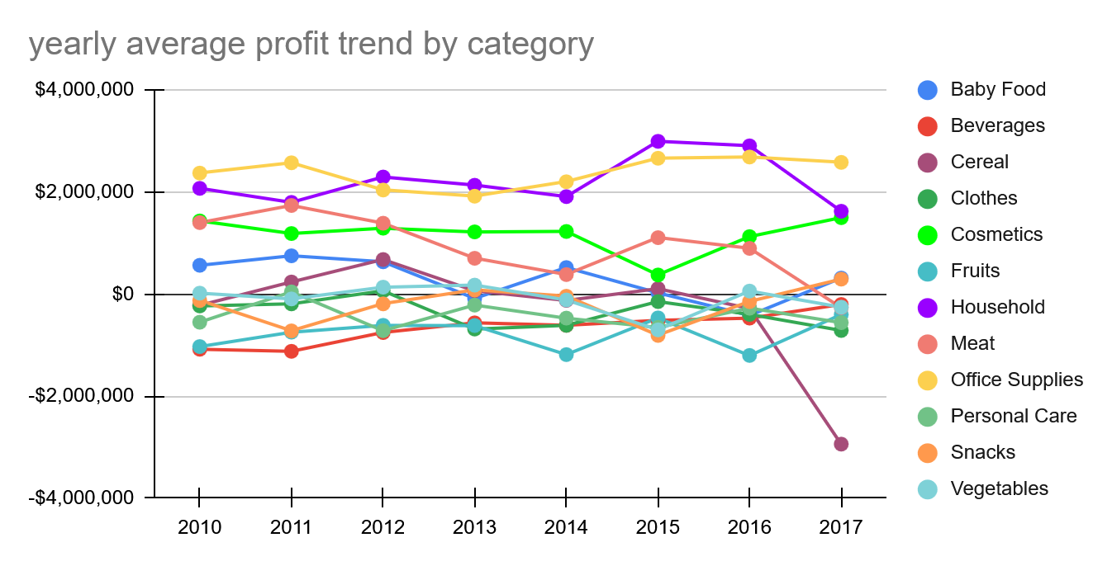

As for yearly trends, office supplies have kept consistently profitable across the years, while household items have taken a massive down-turn in profitability in the past year (from 2.9 million $ in 2016 to just 1.6 million $ in 2017). Also cosmetics have had an up-turn from 1.1 million in 2016 to 1.49 million in 2017.
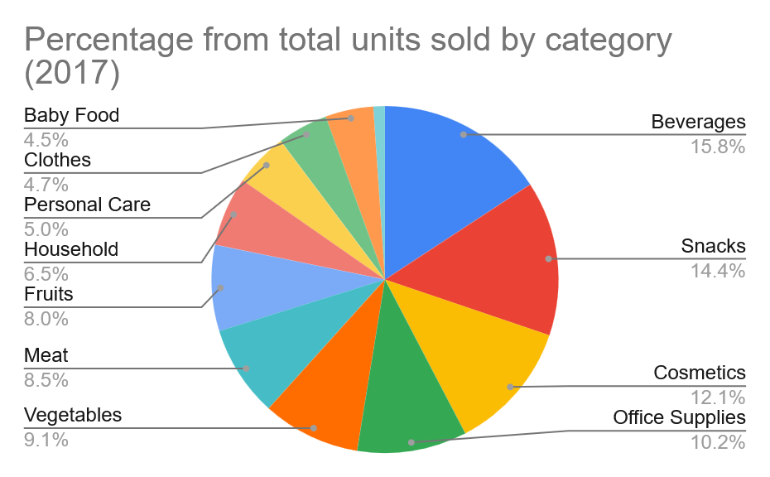
Noticeable is that cereals have recorded a loss of 2.9 million dollars in 2017, when losses for 2016 were around 300k.

Looking only at the past year we see that beverages, snacks, cosmetics and office supplies make up around 52% of total yearly units sold.

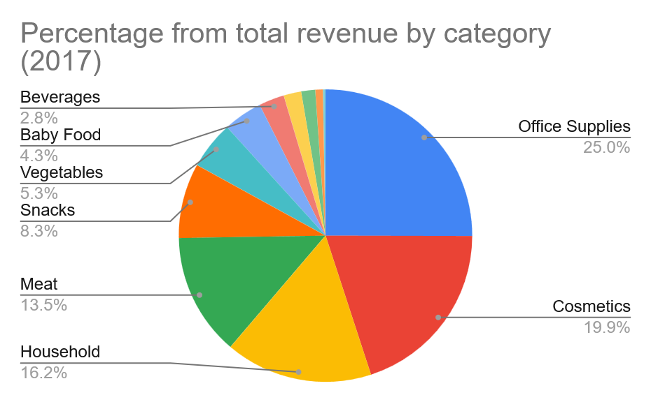

However looking at total revenue we see that office supplies, cosmetics and household items make up 61% of total yearly revenue.

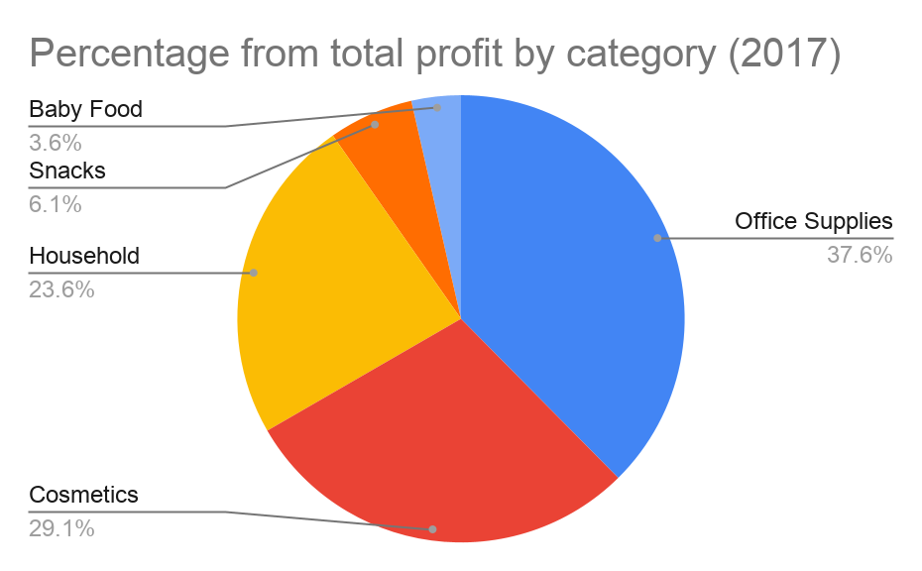
And when looking at the total yearly profit we see that office supplies, cosmetics and household items make up 90% of total yearly profits.

As the data for perishable items suggests massive losses, due to market trends and high costs, coupled with average sales figures and the sales data suggest a shift towards non-perishable daily use personal items, this report concludes that a stronger focus should be put towards those product categories looking to reduce possible costs and increase visibility, while striving to diminish the losses on perishable items, perhaps by under-stocking them.

